When I try to change the woocommerce_thumbnail image size, it doesn’t work. It looks like the size is (262px x 360px) hardcoded into the Ocolus theme. Can you please advise the best way to change it?
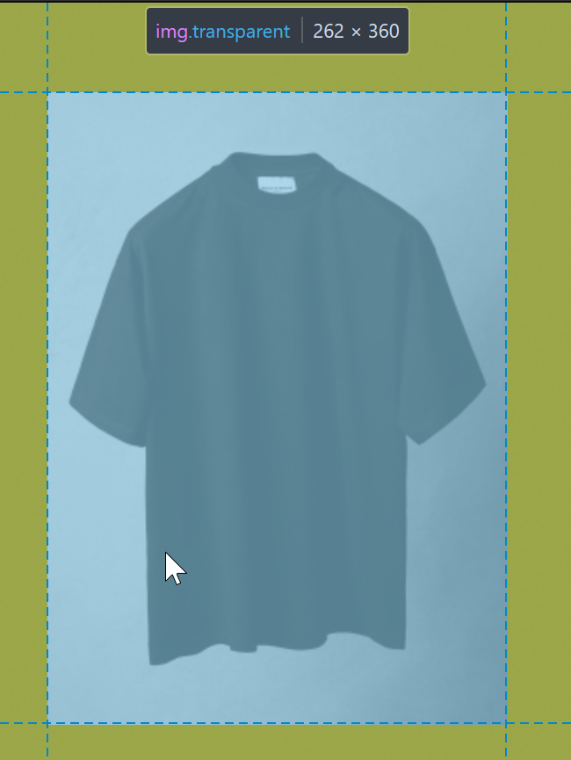
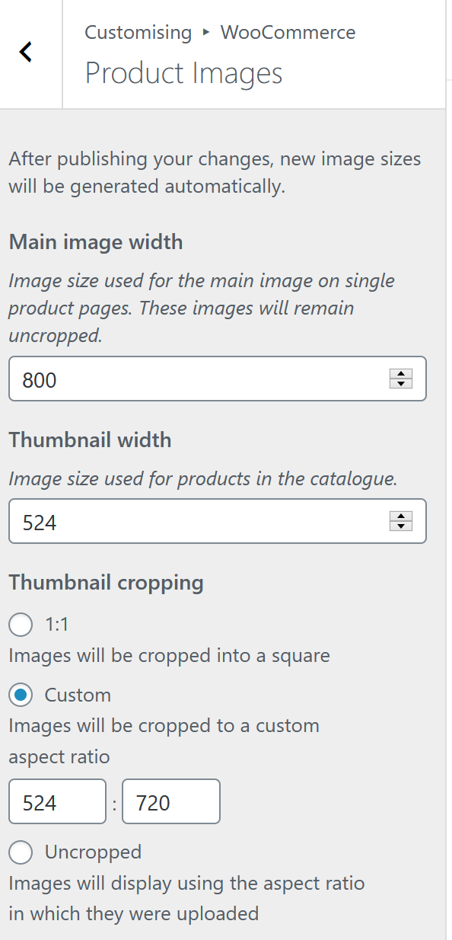
We want to increase the image resolution for the thumbnails by roughly 2x to check the quality/ speed trade-off.
