Top Bar
- Text Colour – Change Grey to White (Icons colour is good, so please don’t change) and Font needs to be bolder – Montserrat 500
- When Hover colour changes to white which is OKAY so please don’t change.

Mega Menu
- Change colour of all text to white like Catagories, at the moment grey for all menus which is not visible. Font for menus needs to be bolder – Montserrat 600 (where is the setting to do that?)

- Line under the mega menu in picture below – part white part blue – please change all to blue.

Mega Menu
- Category part, when hover changes to Grey, change that so it changes to Blue just like all the other menus on the bar as per picture below.

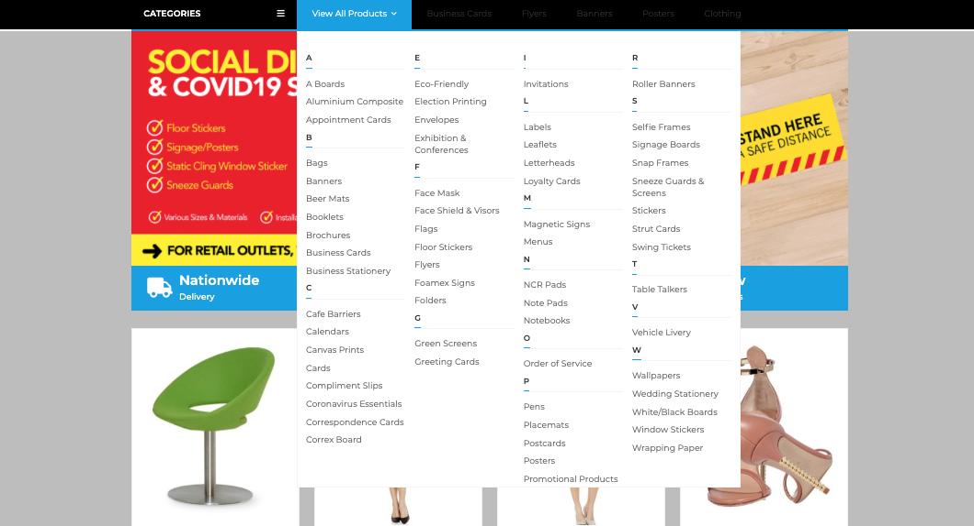

Blue Section where is says Nationwide Delivery etc.
On mobile devices it doesn’t scale. It just splits into 4 rows which looks very big on mobile. Where is the option to resize?

There is a Space under Signup form and above Footer section. Where is the option to remove that space.

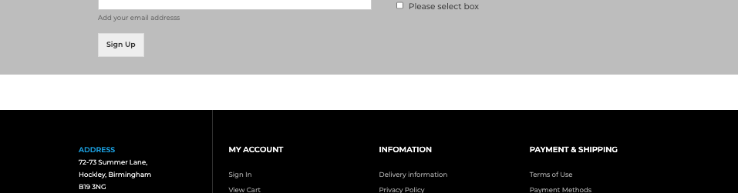

Where is the option to change the colour of Social media icons. At the moment blue, red etc. I want all of them to be Grey but when hover over then they change to actual colours like now the way they are.

At the moment its otherway round – colour first they grey
I want grey first – Colour after once hover over

- Once burger menu is clicked on catagories it stays open, where is the option to auto close.

- Vertical menu
Once link is selected it drops down.
At the moment it has grey background and text colour blue

How do I change background to solid blue and text white. Where is the option to change colours for vertical mega menu?

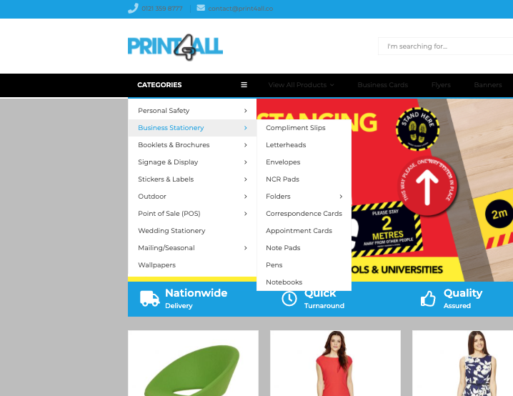

Most of the changes are do with Mega menu or top bar colour changes. Normally in the past always themes comes with mega menu options to do all but I am struggling to find these options in this theme. Please help.

